CV-
ONTARIO
SUPERIOR COURT OF JUSTICE
b e t w e e n:

plaintiff
and

defendant
affidavit of [NAME OF DEPONENT]

I, [name of deponent], of the City of Ottawa MAKE OATH AND AFFIRM:

- I am the [nature of relationship to proceeding] and, as such, have personal knowledge of the facts and events to which I hereinafter depose. Where I do not have personal knowledge of these matters, I state my belief and the source thereof.

- I make this affidavit for the purposes of this litigation and for no other or improper purpose.

Affirmed remotely before me pursuant to | )
O.Reg 431/20 at the City of Ottawa | )
to the City of Ottawa, | )
on | )
 | )
 | )
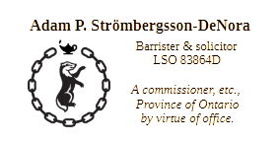 | )  )  )  )  )  )  )  )  ) | Deponent
 | )

CV-
Superior Court of Ontario
PROCEEDING COMMENCED AT OTTAWA

AFFIDAVIT OF [NAME OF DEPONENT]

A.P. Strom & Associates
735 – 1 Rideau St.
Ottawa, ON. K1N 8S7
t. 613.699.2127

Adam P. Strömbergsson-DeNora
LSO 83864D
e. adam@apstrom.ca
t. 613 699 2127

